A historic event venue space that was originally the lobby for The Chestertown Bank built in 1849. It has three tall arched windows that extend from the wainscoting to the 20’ high ceiling and an octagonal skylight with a large, elegant chandelier that adorns the space. Depicted in the logo is the detailed woodwork that encompasses the skylight and balcony. The floors are hardwood with the original tile center, perfect for a dance floor! The most unique feature of this space is the walk-in safe that is filled with empty safe deposit boxes.

MAX CAPACITY
- 80 for a seated dinner or 115 for cocktails

SET UP/ CLEAN UP
- Any rentals are to be dropped off Friday morning and picked up Monday morning.
- All decorations and personal items are to be removed immediately after the event.

EVENT PARKING
- Guests will use public parking spaces on High Street and its surrounding streets.
- Vendor and handicap parking are available in the parking lot behind the building around the center island only (posted as KRM Development).

HANDICAP ACCESSIBILITY
- For persons needing handicap accessibility, there is a side entry/exit door. Please use the rear parking lot and access the side door from the alley to the left of the building.

REQUIREMENTS
- Landlord requires a $1,000,000.00 Certificate of Liability from Tenant naming Landlord as additional insured.
- Tenant must provide Landlord with a list of their vendors along with the vendors’ certificates of insurance.
- The above requirements are to be provided to Landlord at least two weeks prior to the event.

VENDORS
- Vendors should use the rear parking area for their vehicles and drop-off/pick-up. However, it is understood that the front door may need to be used for certain items.
- Caterer is responsible for hauling any trash from the event that does not fit neatly into the Landlord’s two trash receptacles.

FURNITURE
- We have the following items available for your use:
  - 10 five-foot round tables
  - 80 wooden folding chairs
  - 2 six-foot banquet tables
  - 2 eight-foot banquet tables
  - 6 three-foot round cocktail tables
  - Ivory linens for tables (additional fee)
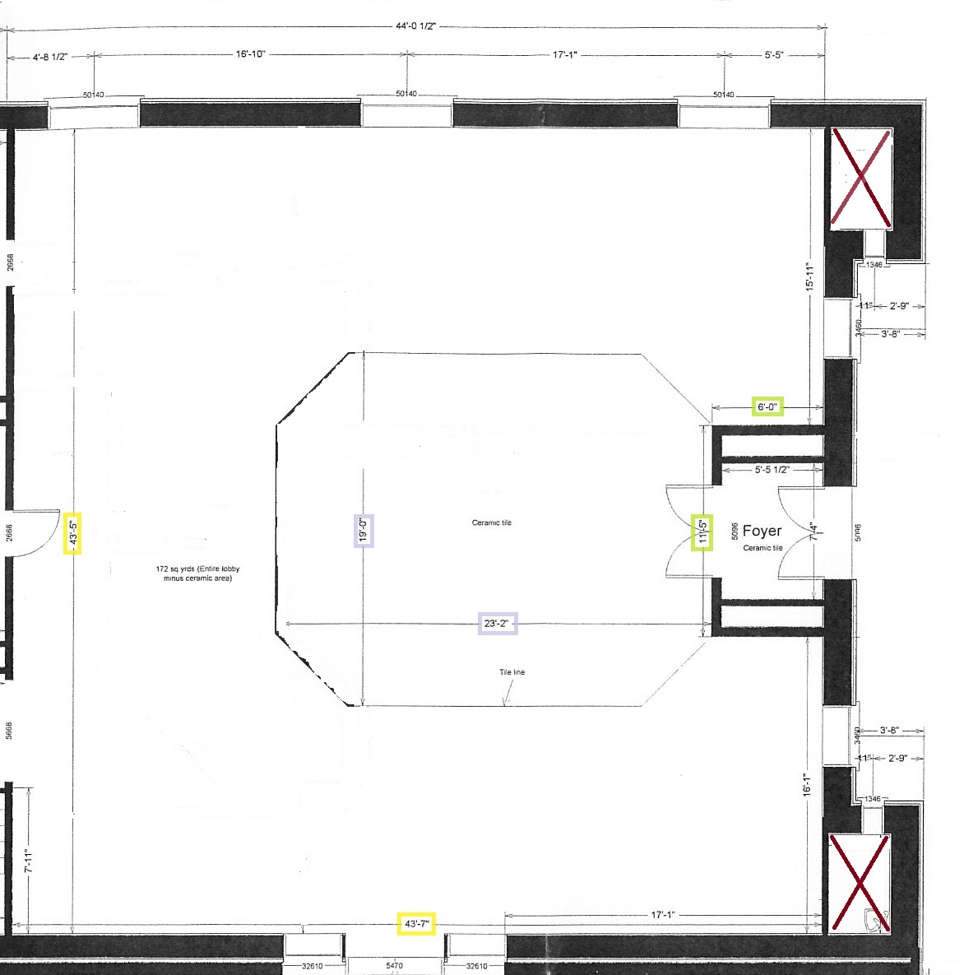
- We need to know what furniture you’ll need at least two weeks before your event.

